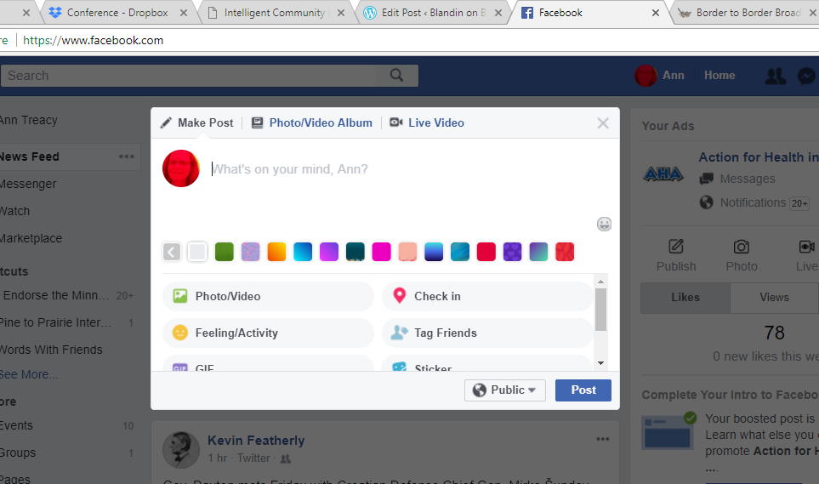
TO LIVESTREAM FROM YOUR PERSONAL ACCOUNT
- Open Facebook
- Click on LIVE VIDEO
- Enter a Title for your video and click start
- Keep an eye on the video, you may need to reconnect if the video stalls.
- Good news – if the video stalls it will not automatically cut off the video.
- Once completed click on finish and opt to post the archive
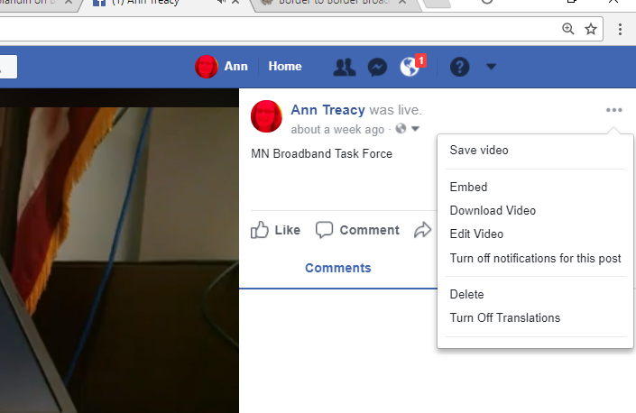
TO ARCHIVE YOUR OWN VIDEO
- Open the posted video
- Click on the three dots on the right corner of the open window
- Choose DOWNLOAD VIDEO
- This may take a while depending on your broadband.
- Tip: Use a wifi connection, not your cellular service
TO ARCHIVE SOMEONE ELSE’S VIDEO
- Get the address of the video (the above example is at https://www.facebook.com/annttreacy/videos/10155847750088417/)
- Replace www with m like - (https://m.facebook.com/annttreacy/videos/10155847750088417/)
- The follow steps 2-7 above
TO LIVESTREAM DIRECTLY TO A PAGE YOU MANAGE
- You'll need to have the Facebook Pages Manager app to stream live video to your Page.
- Go to your Page in the Facebook Pages Manager app
- Click Post to create a new post
- Click "Go Live"
- Add a description for your video
- Click "Go Live"
TIPS:
- Share the video with folks/page who might be interested
- Let people know in advance you will be streaming
- For many public meetings audio is more important than video
- You can download the archive and upload to YouTube for backup and for easier sharing on other social media

