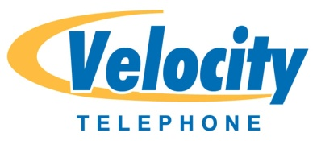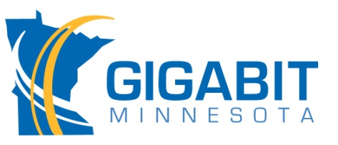
Velocity Telephone brings Gigabit Minnesota to Rosemount MN
July 23, 2014
Rosemount MN — Velocity Telephone, Inc. of Golden Valley MN has acquired the assets of FTTH Communications in Rosemount MN and is bringing Gigabit Minnesota to the City of Rosemount. Gigabit Minnesota, as its name suggests, will make Rosemount the first Gigabit City in the Metro Twin Cities area of Minneapolis/St Paul. Gigabit Minnesota plans to provide the highest speeds available for Internet, television service and home telephone service.
“Becoming a Gigabit Fiber City is a real selling point for Rosemount,” said Mayor Bill Droste, “Velocity Telephone bringing Gigabit Minnesota to Rosemount will bring local ownership to a franchise that has struggled in the past and is committed to the growth and future of Rosemount.” Jim Hickle, President of Velocity Telephone and Gigabit Minnesota is a long time Rosemount resident and is very excited to make Rosemount the “Fastest City” in Dakota County. “We have worked long and hard on acquiring FTTH and know that now is the perfect time to bring Fiber Internet speeds to my friends and neighbors in Rosemount.”
Gigabit Minnesota
Velocity Telephone has been offering Internet services since 1997 and has been offering fiber based services to many Twin City businesses since 2009. “Fiber is a breakthrough technology that will dramatically change the way users connect with their world,” Jim Lundberg, chief executive officer of Velocity, says. “We fully expect our customers to have a much better overall customer experience with faster Internet and local customer service and support. Velocity is very excited to expand this technology in Rosemount.”
The Gigabit Minnesota brand expands Velocity into the residential fiber business. Velocity has already been working on the necessary network upgrades to improve the current FTTH customer’s services and have been building fiber in the many new housing developments in Rosemount. “Our construction division has been very busy working with FTTH building fiber and trying to stay ahead of the demand in these new housing areas even before we completed the acquisition,” states Jim Hickle, “and we will be looking to break ground in other new pilot “Fiberhoods” in 2015 where there is sufficient interest.”
Crystal Clear Voice, Video and Data Transmissions
Velocity is a Research and Development Company committed to maximizing the benefits of fiber including Gigabit speeds (up to 1000Mbps), Home Security Systems, lower cost fiber deployment methods, TV Anywhere and much more. Fiber optic cable has the ability to carry large amounts of data and allows Velocity to stay on the cutting edge as technology evolves. Voice, Video and Internet over fiber are crystal clear and less susceptible to interruptions caused by outside sources. Fiber technology is literally future-proof. Today, customers need and demand more and more bandwidth…and fiber delivers on that promise now and in the future.
Velocity Telephone, Inc. d.b.a. Gigabit Minnesota is a Minnesota based company that was founded in 2000. They provide local customer service and support for both residential and business customers. Its sister company is USFamily.net, one of the Twin Cities oldest Internet Service Providers founded in 1997.

